Sacramento County Approves Second “Safe Stay” Site
7/13/2022
Homelessness

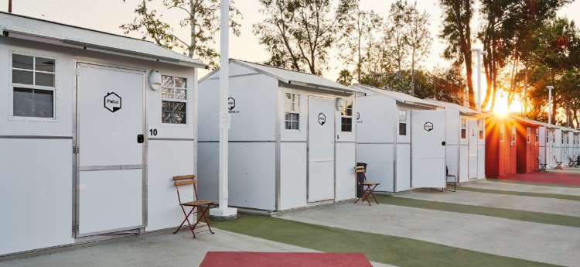

Article Date: Wednesday, July 13, 2022
The Sacramento County Board of Supervisors approved yesterday Sacramento County’s second proposed “Safe Stay Community” for persons experiencing homelessness. The second community will open at 7001 East Parkway in part of the parking lot of the current County Department of Health Services building. The site will house up to 45 Pallet sleeping cabins – both single and double occupancy, bathrooms, and communal gathering spaces. At any point in time, it can shelter up to 56​ people.

The first location, at 8144 Florin Road (near Power Inn) was approved on June 8 by the Board and will have 100 sleeping shelters that can accommodate up to 125 at any given time. Both locations will be operated by an experienced provider that will handle on-site staff, and manage neighbor relations and the day to day needs of the community.

These communities are built as a safer and more sanitary environment and offer c​ritical services oriented towards exiting to permanent housing. Each site will include 24/7 security, case management services, on-site power, sanitation and food services. The County will develop good neighbor policies for the operator and occupants as well as create an oversight committee made up of County staff, community members and those with lived experience to help further guide progress in the County response.

“I am thrilled to have a second location approved and ready to build in District 2,” said District 2 Supervisor Patrick Kennedy. “The need in our area is great. These new Safe Stay Communities will go a long way to help those in South Sacramento experiencing homelessness with stable shelter, drug and alcohol services, mental health services, job training, and a connection to other vital services that will lead to a healthy lifestyle and self-sufficiency while providing relief to the businesses and residents in the community that have experienced the impacts of homelessness.”

Guests for every Safe Stay Community will be brought in from the immediate neighborhood, not only providing direct relief to the community, but providing local and dignified shelter in an area the guest is familiar with.

The East Parkway location will likely move on a parallel timeline as the Florin and Power Inn location and will hopefully welcome guests early next year.

While homelessness can be successfully addressed by providing stable, affordable housing, combined with appropriate support services, this approach can take many years. Safe Stay Communities provide immediate safe and hygienic locations for persons experiencing homelessness to live and access services. The communities also provide a consistent location for service providers and outreach workers to engage on a more regular basis with occupants.

Additionally, some of the broader community benefits anticipated by having this safe space community include a reduction in trash and debris, the mitigation of environmental and health hazards, and the ability to restore land previously occupied by unsanctioned encampments to its intended use.

For more information on Safe Stay Communities, read our “Safe Stay Community FAQs.”

For more information about Sacramento County’s response to homelessness, visit our website.

